

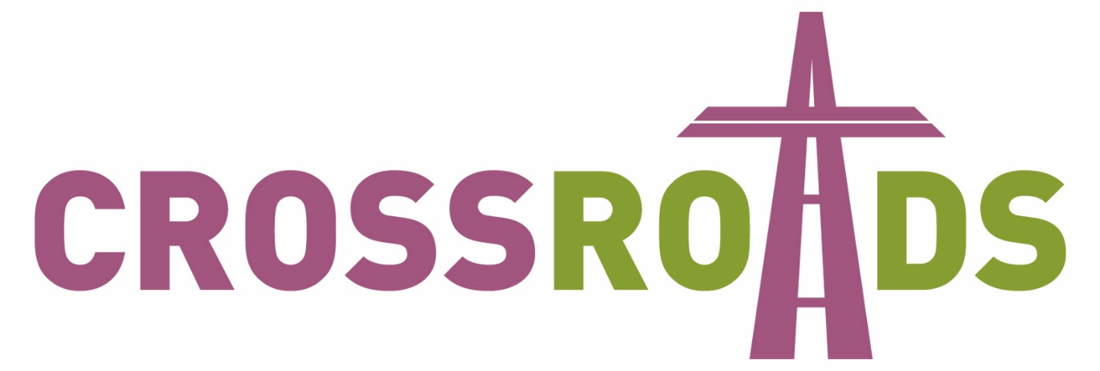

Northern Bishops’ Mission
Blackburn Diocese
8-11 September 2016

Event Planning Template
What is Crossroads?
Crossroads is an opportunity for us as a diocese to unite in locally organised mission, outreach and evangelism. Archbishop Sentamu, together with the Bishops of the Northern Province and their teams, will be working in our diocese from 8th – 11th September 2016. We anticipate having about 15-20 Bishops visiting our diocese alongside 14 or 15 teams composed of a mix of lay people, youth workers, ordinands and clergy. The essence of Crossroads is local churches engaging in local mission. The events and style of the mission are decided at local church and deanery level, with the visiting mission team supporting what has been decided by parishes.
How will Crossroads be organised?
One (or more) Bishops, together with their teams, will be allocated to each deanery. Archbishop Sentamu’s office have sent invitations to the Bishops, and, once responses are received, Bishops and their teams will then be allocated to deaneries. Deaneries are therefore key to the planning of this mission, and each deanery will have a Deanery Co-ordinator who is responsible for scheduling the Bishop and their team to events across the deanery.
Using the planning form
This form is intended to aid your planning, and also to help your Deanery Co-ordinator to schedule events across the deanery, ensuring we make the best use of the visiting team over the course of the mission.
Please complete section one. Section two includes some questions you may wish to consider, and is to aid your own planning. Once complete please send this form to your deanery coordinator, so they can fit the events into an overall deanery plan and share this with the visiting Bishop and their team.
If you have any questions about this form please contact your Deanery Coordinator or Rev Grant Ashton (Deanery Co-ordinator Liaison) on euxton.vicar@gmail.com, 01257 262102.
Section one: Information
Name of parish or school
Named contact of person organising this event
Telephone number
Email address
Name of event and brief description
Venue
Date and time of event
Which level is your event? (please tick)
Level One - These events are mainly social with a very small amount of Christian content. This type of event is ideal for first contact with people.
Level Two - An event that provides more information about the Christian faith and encourages people to explore further.
Level Three - These type of events explain clearly the central message of the Christian Faith, present people with the benefits and costs of choosing to be a committed Christian and present a clear invitation to respond to Jesus.
How would you like the visiting team to assist you with this event? (e.g. evangelistic talk, chatting to guests, encouraging church members to share their faith, practical assistance etc.)
Are there any specific skills or experience you require the visiting team to have for this event? (e.g. schools work, interfaith.)
Please provide a rough running order for the event, including timings and when you expect that the team will be used.
Will you be serving any food or refreshments? If yes, what do you plan to serve?
What resources do you require for the event? Where will you get them from?
Section two: Other things it would be helpful to consider
Who will you be inviting?
How will you invite them?
Who from your local context is helping with the event, and how will they be involved? (e.g. parishioners serving refreshments, John overseeing audio and video, 5 parishioners are going to circulate and chat with guests, Sarah overseeing welcome team etc.)
After the event….
What impact do you hope the event will have on:
- Guests
- The local community
- Parishioners?
Will there be any follow up after the event?
How will you follow up guests?
Will you be running an enquirers course?
When will this start?
How does this event fit into the ongoing work in your parish, and Vision 2026?

